Bakery website describtion

Over view: The web project we are working on is a comprehensive and interactive multi-page website designed to engage users and offer them a variety of services, information, and functionality. This project consists of 7 distinct pages, each built using HTML, CSS, and JavaScript to deliver a seamless and dynamic user experience. Below is an in-depth description of each page and what it does:

**1. Home Page (Welcome Page)**

The Home page serves as the introductory page for visitors, welcoming them to the website. It provides an overview of your brand or business, offering a glimpse into the story behind it. The page has an inviting design, aimed at creating a connection with potential clients. A prominent feature of the Home page is a button called **“Explore Our Menu”**. When clicked, this button redirects users to the **Product (Menu) Page**, allowing them to learn more about the offerings your business provides.

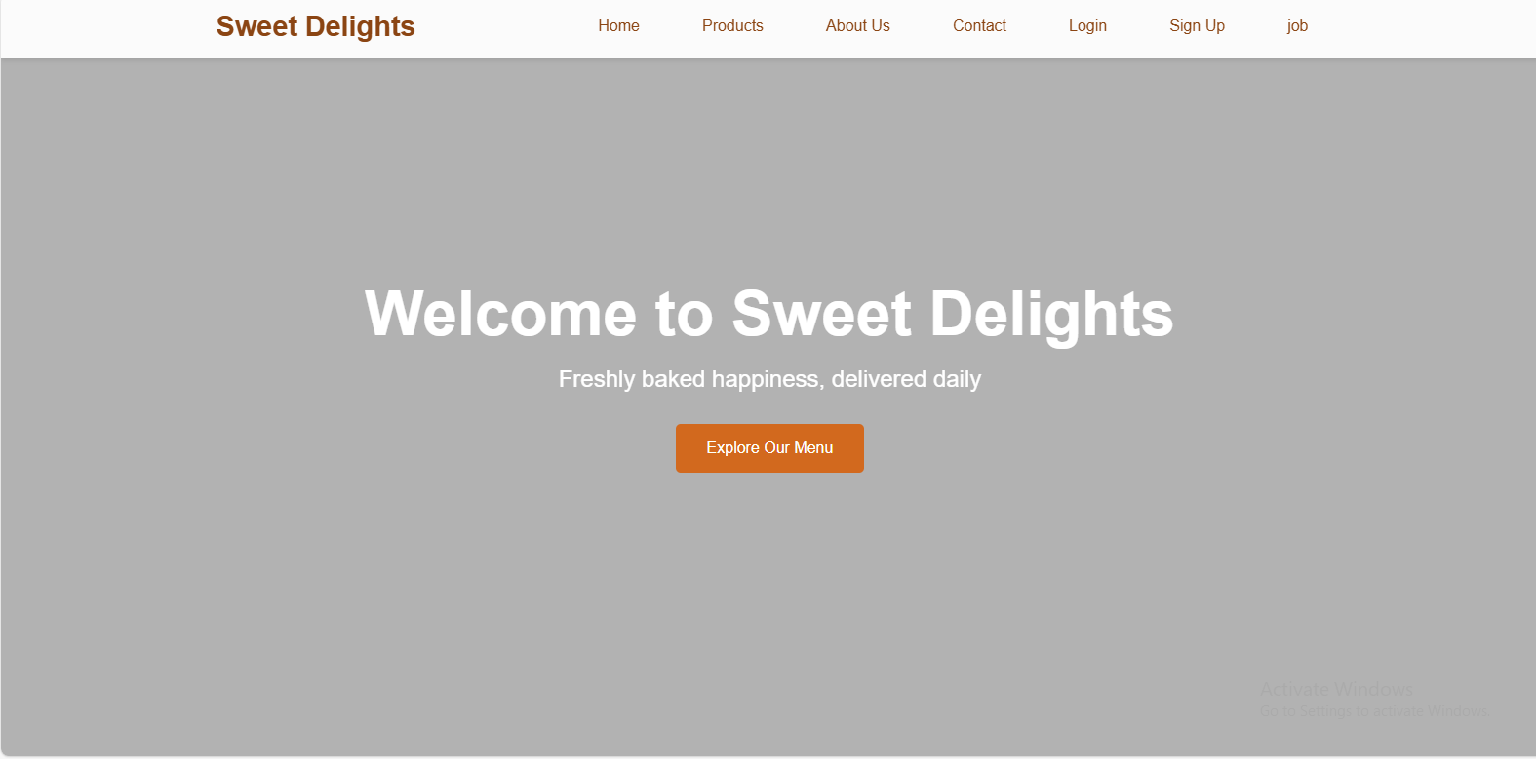

**2. About page**

The about page offers an in-depth description of your business, its origins, values, and mission. This page gives visitors the chance to learn about the history behind the brand, its growth, and what drives the business forward. It's an essential page to help build trust and connect with potential customers or partners, as they gain insight into what makes your business unique.

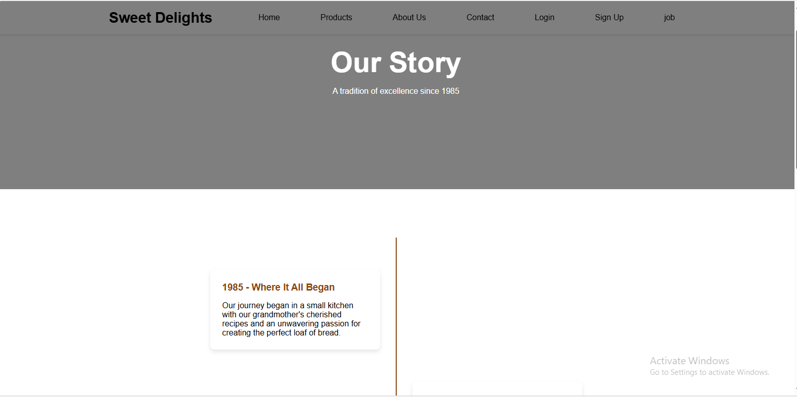

**3. Product Page (Menu Page)**

The Product page, also referred to as the **Menu Page**, showcases the core products or services your business offers. This page is essential for providing users with detailed information about your offerings, including descriptions, pricing, images, and any special promotions. It could be structured as an interactive menu, where customers can browse through various product categories or services, select items, and learn more about them. This page plays a key role in driving sales and customer engagement.

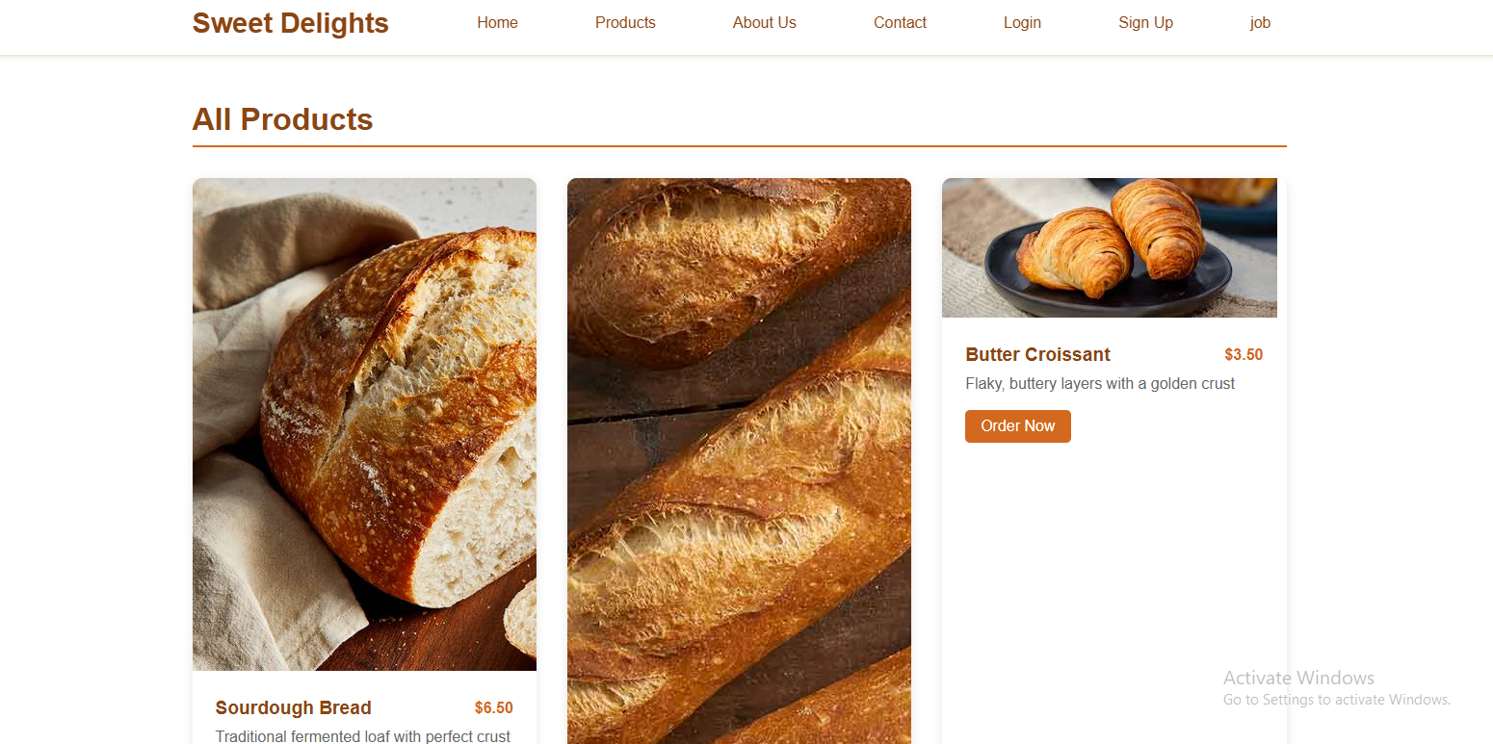

**4. Contact Page**

The **Contact Page** is designed to provide visitors with all the necessary information to reach your business. It contains details such as:

* **Physical addresses**: The locations where customers can visit or contact you.
* **Phone numbers**: Multiple contact numbers for customer service or other business inquiries.
* **Business hours**: The days and hours when your business is open and available to serve customers. This page is essential for customers who need assistance, want to make inquiries, or visit your physical location.

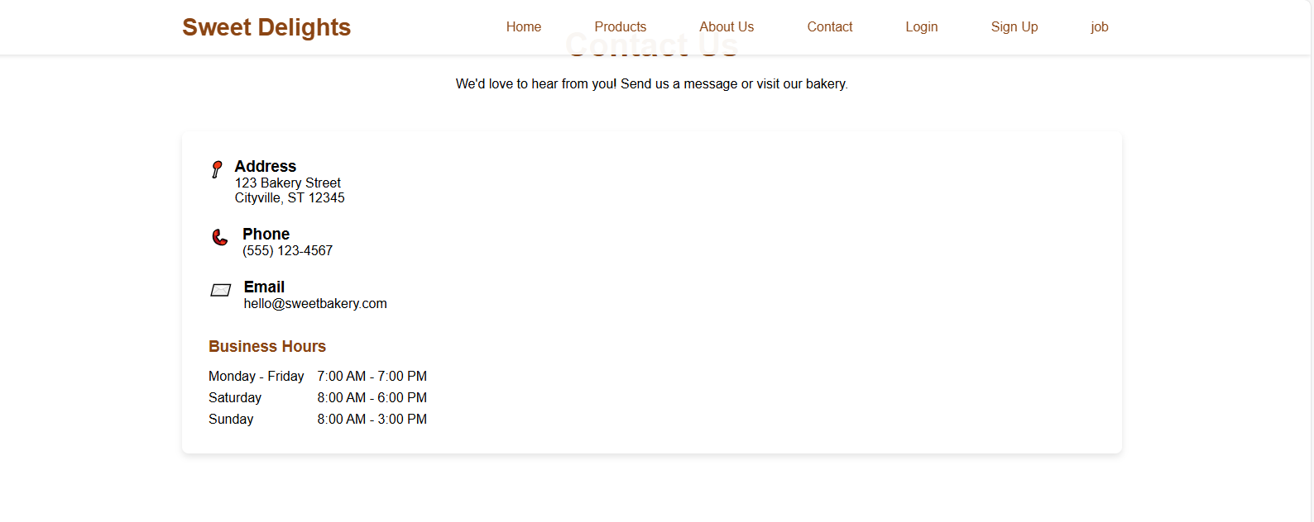

**5. Job Opportunities Page**

The **Job Page** serves as the section where potential candidates can find out about the available job opportunities at your business. It provides a list of open positions, job descriptions, and the skills required for each role. If candidates are interested, they can apply directly through the website. This page helps with recruitment and lets users know that your business is growing and actively looking for talented individuals to join your team.

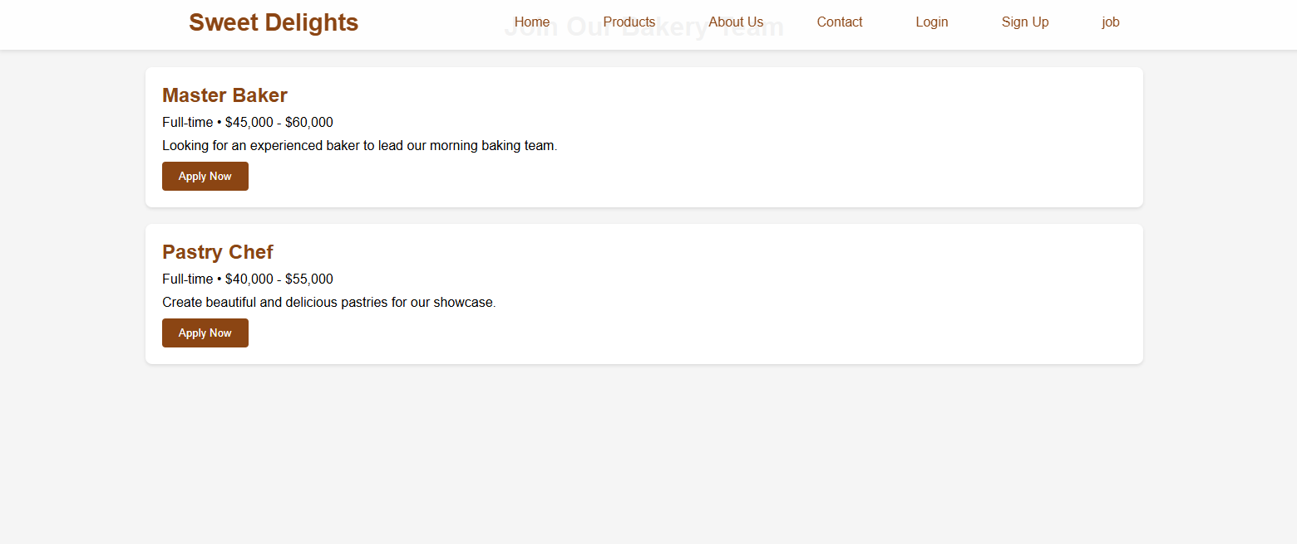

**6. Sign Up Page**

The **Sign Up Page** allows new users to create an account on your website. It includes a form where users can input their details, such as their name, email, password, and other necessary information. This page is crucial for businesses that want to build a customer database, offer personalized services, or require account creation for further interaction with their services (such as ordering products or applying for jobs).

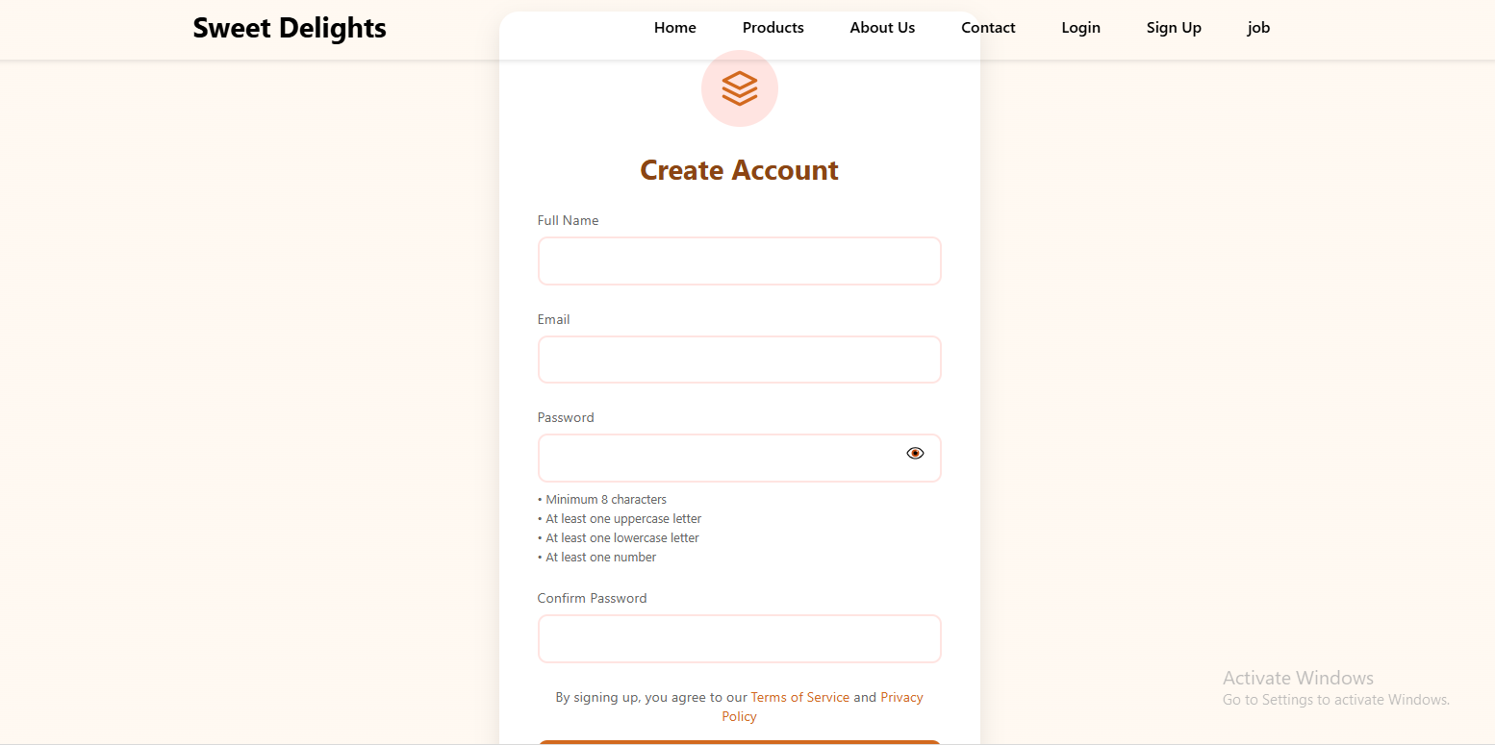

**7. Login Page**

The **Login Page** is where returning users can access their personal accounts by entering their credentials (email and password). This page ensures that users who have already signed up can securely access their information, place orders, manage their profiles, or apply for job positions. The login system is vital for any web application that requires authentication, ensuring that users' data is protected and personalized services are available.

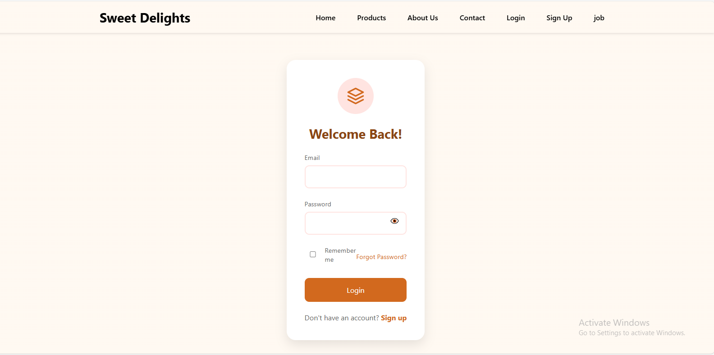

**Key Features and Technologies:**

1. **HTML**: The backbone of the site, structuring the content and organizing the pages with appropriate tags (headings, paragraphs, lists, forms, etc.).
2. **CSS**: Used for styling and creating an appealing, user-friendly design. This includes layout adjustments, colors, fonts, and interactive elements like buttons and navigation bars.
3. **JavaScript**: Enhances the interactivity of the website. This could involve form validation (for the Sign Up and Login pages), dynamic product displays (on the Product page), smooth navigation (via buttons and links), or handling job applications.

**Overall Purpose and User Journey:**

This web project is designed to provide a seamless experience for users, offering them information, products, and services in an intuitive manner. The journey begins with an engaging welcome on the Home page, where users are encouraged to explore further by navigating to the Story and Product pages. The Contact and Job pages provide essential functional information, allowing users to get in touch or apply for roles, while the Sign Up and Login pages facilitate user registration and personalized services.

This well-rounded design is ideal for businesses looking to offer both customer engagement and operational functionality through their website. Whether users are exploring your product offerings, learning about your brand’s story, applying for jobs, or accessing account-based features, the website provides a streamlined and welcoming experience.